
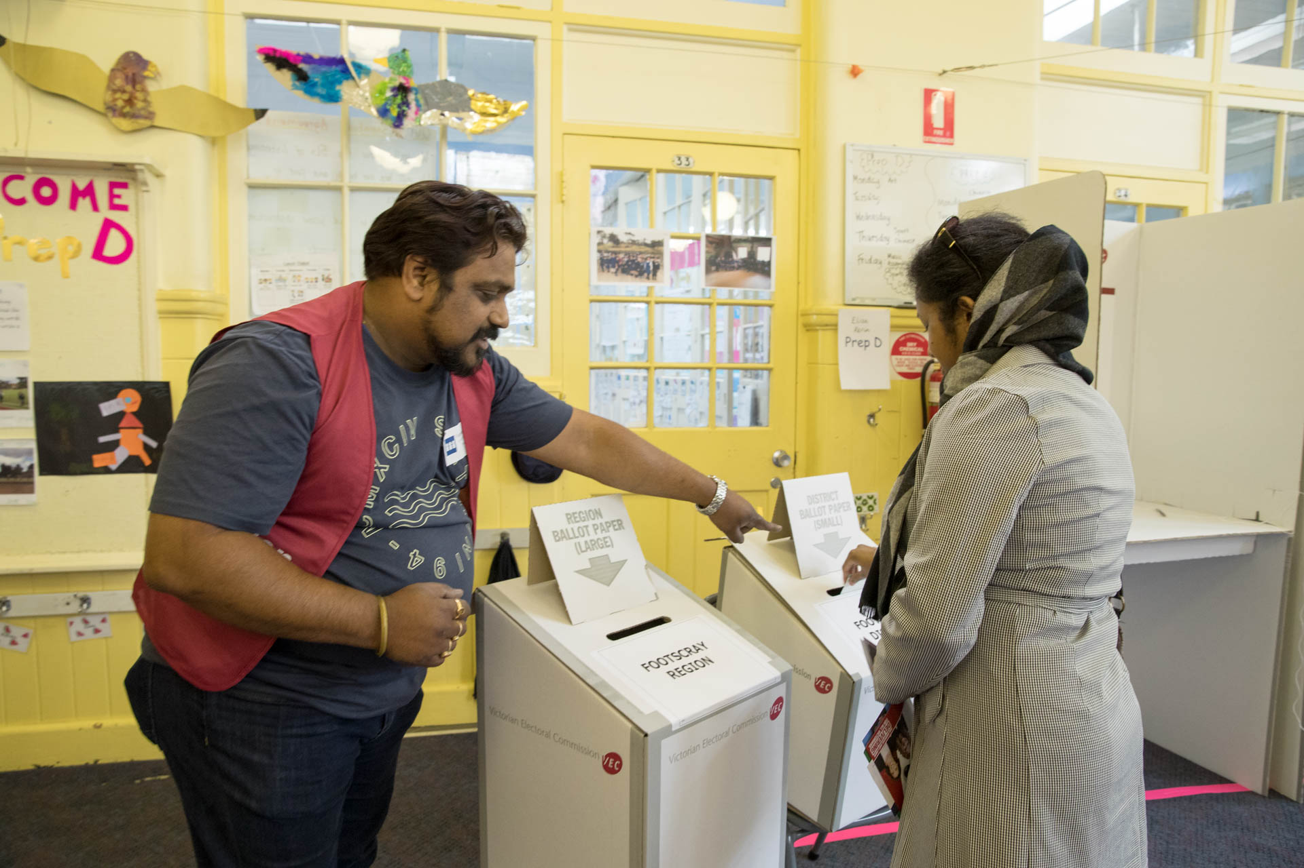
Voting centre accessibility report – Key points
Plain language guide
Electoral Matters Committee

Contents
About this guide Page 3
Everyone should be able to vote Page 4
A new approach to accessibility Page 5
Choosing voting centres Page 9
Making voting centres more accessible Page 11
Equipment at voting centres Page 13
Better information for voters Page 15
Features of voting centres Page 16
Helping voters explain what support they need Page 17
Training and supporting staff Page 18
Conclusion Page 20

About this guide
We are the Electoral Matters Committee. We look into how elections are run and the laws that affect elections in Victoria.
An election is when people vote for the person they want to represent them.
We wrote this plain language guide about making voting in Victoria more accessible.
Accessible means everyone is able to find and use something.

Everyone should be able to vote
Everyone who is allowed to vote should be able to vote.
This is what makes a healthy democracy, which is where everyone gets a say in how things are done.
However, people with disability can face barriers when they vote. These barriers can make voting harder and sometimes impossible.
The Victorian Electoral Commission (the VEC) holds elections and makes sure everyone plays by the rules when they vote.
The VEC has already made changes to improve access to voting. They have removed some barriers and given people different ways to vote.
We support these changes, but we know that more needs to be done.

A new approach to accessibility
Accessibility means making sure everyone can use something, no matter what their needs are.
Accessibility is not the same across different voting locations. It can depend a lot on individual staff members, instead of being built into the voting system.
Sometimes, what everyone needs is not thought about.
The VEC needs a new approach to accessibility when it comes to voting.
It should:
- make accessibility a key part of how elections are planned
- set clear actions and targets for improving accessibility
- check if projects to improve accessibility are working
- publicly report on what it is doing and whether it is making a difference.
The VEC needs to think differently about accessibility.
We recommend 3 guiding principles.
Principles are a set of rules that help us to know how to behave and work.
- Make accessibility part of the design
Services and systems should be accessible from the beginning wherever possible.
Accessibility should not be added later to systems that were not designed for people with disability.
- Look at the whole voting experience
Accessibility should be considered at every stage of voting.
This includes:
- finding information about the election
- travelling to a voting centre
- entering the voting centre
- waiting in line
- voting
- leaving the voting centre.
- Recognise that disability is diverse
People with disability have different experiences and different access needs.
This includes people with:
- physical disability
- psychosocial disability
- cognitive or intellectual disability
- sensory disability
- visible disability
- hidden disability.
Using these principles would help the VEC prevent and reduce barriers across the voting process.
The VEC should also consider other barriers that a person may experience as well as disability.

Choosing voting centres
The VEC currently considers accessibility when choosing voting centres, but it is mainly focused on physical access.
This does not cover all the barriers that people with disability may face.
The VEC does not think about if the whole voting experience is accessible. For example, getting to voting centres.
We recommend that the VEC use broader accessibility measures when choosing voting centres.
Accessibility should also be included more strongly in election planning documents.
The VEC has sometimes had difficulty finding early voting places that are accessible.
We recommend that publicly funded venues, such as council community facilities, should be made available for early voting.
The Victorian Government could also consider including accessible voting venues when they are planning new public buildings.

Making voting centres more accessible
The way a voting centre works can either create barriers or reduce them.
We identified several areas that could be improved, including:
- managing queues
- the layout of voting centres
- signs and directions
- drop-off areas.
The VEC should also improve the way it supports people who find it hard to go inside a voting centre. For example, some people may need ballot papers brought to their car.
Accessibility tools should also be easy for voters to find and use.
We recommend investigating a system used in New Zealand called takeaway voting.
Takeaway voting lets someone collect ballots for another person, take them away so the other person can vote, and then return them to the voting centre.
A ballot is a piece of paper that you use to vote.

Equipment at voting centres
People with disability need suitable equipment so they can vote.
Voting booths could be designed better for people with disability. For example, some voting booths should have enough room for a support person.
There may also need to be more accessible voting booths available to voters.
Voting centres should provide more seating for people who need it before, during and after voting.
Communication aids are also important.
Personal hearing amplifiers are available at early voting centres. Where possible, they should also be available at voting centres on election day.
Communication boards have been available at previous elections, but they were not available in 2022. We recommend bringing communication boards back to voting centres.
Some people also need specialised equipment so they can vote independently and privately.
The VEC should explore options such as:
- assistive reading technology
- different types of writing tools.
The VEC should ensure that:
- there is enough accessible equipment available
- staff know what equipment is available
- voters know what equipment and support they can use
- voters can easily access the equipment they need.

Better information for voters
There are gaps in the information available to voters with disability.
Information should be available in different accessible formats.
People need accessible information before they vote and when they are at a voting centre.

Features of voting centres
At the moment, information mainly tells people about wheelchair access.
This is not enough for a lot of people to decide whether a voting centre will meet their needs.
The VEC should provide more detailed information about:
- accessibility features at each voting centre
- possible barriers at each voting centre
- accessibility tools and services that are available.

Helping voters explain what support they need
Some voters may need an easier way to tell voting centre staff about their access needs.
One option is a voting passport. A voting passport is a form that a voter fills out with information about the support they need.
They could show the passport to voting centre staff instead of having to explain their needs each time.
This could help voters communicate their needs clearly and with dignity.
The VEC should also explore ways for people to tell the VEC about their needs before they vote, if they want to.

Training and supporting staff
Voting centre staff can have a big effect on a person’s voting experience.
Staff need training so they understand accessibility and know how to support people with disability.
The VEC already includes some disability information in staff training, but this training could be improved and expanded.
VEC head office staff should also receive accessibility training. This would help make sure accessibility is thought about when decisions are made.
Training election staff can be difficult because the VEC employs more than 20,000 temporary workers during a state election. These workers have many different jobs and rules to learn.
We recommend testing the use of specially trained accessibility officers at some voting centres.
Accessibility officers could:
- help other staff
- encourage accessible practices
- help voters get the support they need.

Conclusion
The VEC wants all Victorians to be able to take part in democracy.
For this to happen, the barriers faced by people with disability need to be understood and addressed.
The VEC has already taken steps to improve accessibility.
However, we think there is still more work to do.

